Weather App project Documentation

1 INTRODUCTION

* 1. **Overview**

**Designing the frontend of a weather app involves creating a user interface that is visually appealing, easy to use, and provides the necessary weather information in a clear and intuitive manner. Here are some key elements and considerations for designing the frontend of a weather app:**

**Layout and Navigation:**

**Keep the layout clean and organized with a focus on readability. Use a navigation bar or menu to allow users to switch between different views or sections of the app, such as current weather, hourly forecast, and weekly forecast.**

**Current Weather Display:**

**Display the current weather conditions prominently, including temperature, weather icon (e.g., sun, clouds, rain), and a brief description (e.g., "Partly Cloudy," "Showers," "Sunny").**

**Show additional details such as humidity, wind speed, and visibility, but avoid overwhelming the user with too much information.**

**Hourly and Daily Forecast:**

**Provide an hourly forecast for the upcoming hours, showing temperature changes and weather conditions over time.**

**Show a daily forecast for the next few days, including high and low temperatures, along with corresponding weather icons and descriptions.**

* 1. **Purpose**

**Allow users to search for specific locations or use their device's GPS to get weather information for their current location.**

**Display the location prominently, so users can quickly identify the weather forecast for the desired location.**

**Responsive Design:**

**Ensure that the app is responsive and adapts well to various screen sizes, including mobile devices and tablets.**

**Weather Icons and Graphics:**

**Use appropriate weather icons and graphics to represent different weather conditions, making it easy for users to understand the forecast at a glance.**

**Color and Visuals:**

**Choose a color scheme that complements the weather theme and enhances the app's visual appeal.**

**Consider using animations or subtle visual effects to make the app feel dynamic and engaging.**

**Accessibility:**

**Ensure the app is accessible to all users, including those with disabilities. Provide alternative text for images, use proper contrast for text, and follow accessibility guidelines.**

**Loading and Error States:**

**Design loading states for when weather data is being fetched, and error states when there are issues with retrieving data. Communicate such states clearly to the user.**

**2 LITERATURE SURVEY**

**2.1 Existing Problem**

The basic issue with weather apps, he argues, is that many of them **remove a crucial component of a good, reliable forecast**: a human interpreter who can relay caveats about models or offer a range of outcomes instead of a definitive forecast.

2.2 Proposed solution

A simple weather application that displays the current weather, daily forecasts, and hourly forecasts based on search. The Weather is a UI application that allows you to get the Weather forecast.

3 THEORITICAL ANALYSIS

**3.1 Block diagram**

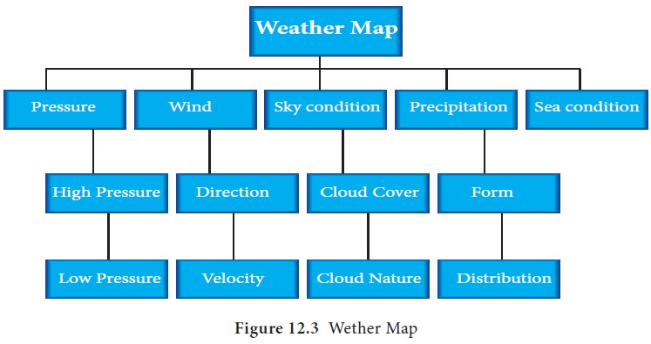

**3.2 Hardware/software designing**

**In weather app we are using hardware is laptop, window version-11.**

**In weather app we are using software is visual studio code.**

**In visual studio code we are using**

* **index.html**
* **styles.css**
* **script.js**
* **API Key**
* **Images**

**4 RESULT**

**This is my project output**

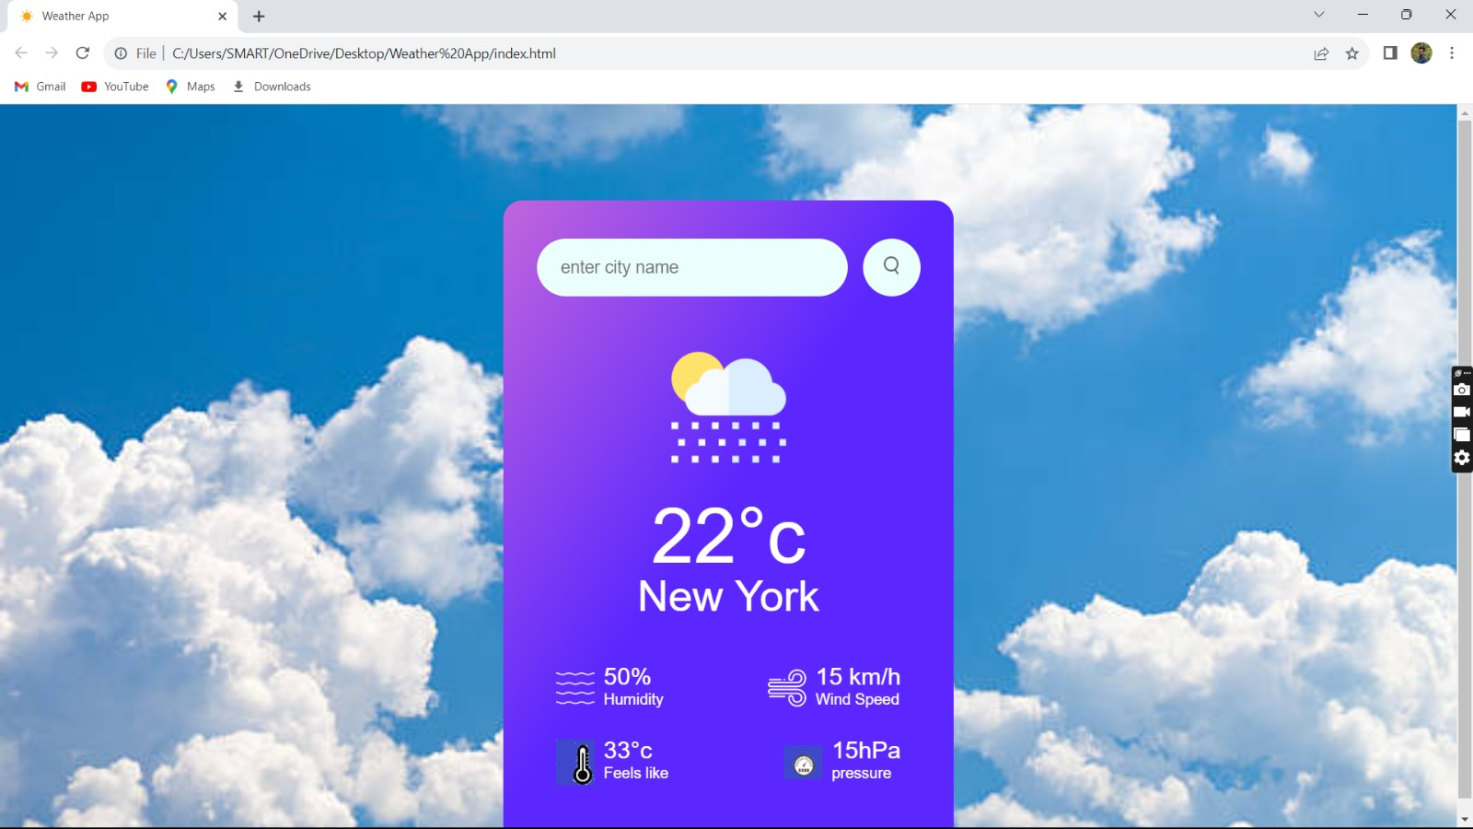

**5 ADVANTAGES & DISADVANTAGES**

**Advantage:**

* Instant information availability
* Improved weather forecast
* Easy flow of information
* Widget support
* Interactive maps for better weather information
* Free availability
* Real-Time Data
* Share Data
* Real-Time Alerts
* Accurate Local Forecast
* Ease Of Use
* Instant information availability.
* Improved Weather forecast.
* Easy Flow of Information.
* Widget Support.
* Interactive Maps for better weather information.

**Weather is something everybody deals with, and accurate date of it like what is coming can help users to make inform decisions. With weather apps for IOS and android people can exactly know when to except a change in the weather conditions . weathers apps can give urgent alerts too.** **Being able to predict and forecast the weather also allows for data to be gathered to build up a more detailed picture of a nation's climate, and trends within .**

**Disadvantages:**

**The weather changes very rapidly, and even the most reliable computer models are prone to error and inconsistencies. The apps do not take geography or microclimates into account and have problems forecasting for snow and thunderstorms.**

**But AI models learn how to produce forecasts using historical weather data — and as the weather grows more extreme, there may be fewer examples of such intense events in the historical record. That means AI systems might not have enough data to accurately simulate unprecedented extremes in the future.**

**Forecasting models have several limitations, such as lack of accuracy, external factors, time consumption, limited scope, and assumption based. These models can be valuable tools for businesses, but they should be used in conjunction with other sources of information.**

**Sometimes weather is extreme, causing destruction and death. Too much rain can cause flooding. Too much hot weather for long periods of time without any rain can cause drought. Huge storms with strong winds, such as hurricanes and tornadoes, can do a great amount of damage to buildings and crops.**

**6 APPLICATIONS**

**A weather app is a way to use your mobile phone to check current, past, or future weather patterns and weather maps. Some apps may have extended functionality, like tracking of ocean tides or the skies**

**An application programming interface (API) key is a code used to identify and authenticate an application or user. API keys are available through platforms, such as a white-labeled internal marketplace. They also act as a unique identifier and provide a secret token for authentication purposes.**

**APIs are used to integrate new applications with existing software systems. This increases development speed because each functionality doesn't have to be written from scratch. You can use APIs to leverage existing code.**

**In User Authorization, API key verifies whether the user making the API call is the same person as the registered user identity. It can also verify the user's permissions when making certain requests to an API. As a result, it can reduce the risk of being hacked by hackers trying to be end-users of the application.**

**Ease of integration. An API is a component that allows different platforms, applications and systems to connect and share information with each other and carry out diverse types of tasks.**

**Better integration. ...**

**Automating tasks. ...**

**Improved services …**

**7 CONCLUSION**

**Weather conditions results from processes that endeavor to level the distinctions in the dispersion of net brilliant energy from sun. At the end of the day, the immediate condition of environment can be called as climate. It is normally communicated as fine, fair, hazy, shady, blustery, bright or breezy weather.**

**weather forecasts are increasingly accurate and useful, and their benefits extend widely across the economy. While much has been accomplished in improving weather forecasts, there remains much room for improvement A forecaster put the latest data onto maps and used his experience with maps of past weather to predict the next day's weather.** **Weather conditions results from processes that endeavor to level the distinctions in the dispersion of net brilliant energy from sun.**

**There are four main elements of weather that can be used to describe the weather and ultimately the climate. They are wind, temperature, air pressure, and moisture.**

**Confidence in attribution analyses of specific extreme events is highest for extreme heat and cold events, followed by hydrological drought and heavy**

**API key authentication is used to validate the calls to our APIs, not the user. In other words, API keys are used to authenticate the applications that send requests to our APIs.**

**Secrets such as API keys are potentially dangerous if they get into the wrong hands. They can be used to change and delete data.**

**An application programming interface (API) key is a code used to identify and authenticate an application or user. API keys are available through platforms, such as a white-labeled internal marketplace. They also act as a unique identifier and provide a secret token for authentication purposes.**

**API key plays an important role in ensuring connections between application services are valid and authenticated. It helps the authentication.**

**The main conclusion of climate prediction models is that human activity increases global warming and raises average world temperatures.**

**8 FUTURESCOPE**

**Weather warnings are important because they are used to protect life and property. Forecasts based on temperature and precipitation are important to agriculture, and therefore to traders within commodity markets. Temperature forecasts are used by utility companies to estimate demand over coming days.**

**Satellites and super computers have revolutionized weather forecasting. The future is exciting—we are looking to promote kilometre-scale climate modelling to better simulate cloud physics, future flooding and drought risks and, for instance, the speed of Antarctic glacier melting.**

**Using artificial intelligence to predict severe weather Much like other industries, artificial intelligence (AI) has entered the weather forecasting space as well. Within weather forecasting, AI is being used for detecting storms.**

**The future of weather applications is promising, with the increasing demand for real-time and accurate weather information. One potential development is the improvement in accuracy through the use of advanced data collection and analysis techniques, as well as sophisticated algorithms.**

**Weather Forecasting is crucial since it helps to determine future climate changes. With the use of latitude, we can determine the probability of snow and hail reaching the surface. We are able to identify the thermal energy from the sun that is exposed to a region.**

**Weather forecasting is just one of the elements of Smart Farming. Beyond just weather, the practice utilizes technology and spatial data points that provide more context than traditional forecasting.**